AutoSTOMP 2.0

Bocheng Yin †, Sarah E Ewald*†

†Department of Microbiology, Immunology and Cancer Biology and the Carter Immunology Center, University of Virginia School of Medicine, Charlottesville VA, USA

*the corresponding author

Contents

1. Imaging system configuration and software 3

1.1 Microscope configuration: 3

1.2 Microscope PC configuration: 4

1.3 Applications needed: 4

2. Mount the slide with biotin-benzophenone 6

3. Prepare microscope and desktop: 7

3.1 Prepare the LSM880 for imaging and load the slide on microscope stage: Start the system, manually inspect the sample. 7

3.2 Open the applications on Windows: ZEN Black, Fiji, Spyder, Sikulix. 7

3.3 Expand the block indicated below in ZEN black GUI: 7

3.4 Set up GUI for Sikulix and Spyder 12

4. Photo-crosslinking with two-photon laser 14

4.1 Setup imaging parameters in ZEN black: 14

4.2 workflow contains two parts: 14

4.2.1 Interactive tools to select interesting regions from single tissue section or multiple ones with “RegionSelection.sikuli”. 15

4.2.2 Iterative photo crosslinking through tiles of SOIs with “STOMP.sikuli” 15

4.2.3 “stp_becalled_oneChannel.sikuli” called by “STOMP.sikuli” 16

4.2.4 The Fiji (also imageJ) macros 17

4.2.5 Other Python scripts 17

4.3 Let’s start!!! 18

4.3.1 run “RegionSelection.sikuli” file in Sikulix 18

4.3.2 open Fiji and install the macro “ROICo_sc.ijm” 25

4.3.3 open Spyder and run the script, “tile_imputation.py” 27

4.3.4 run “STOMP.sikuli” file in Sikulix 27

5. During autoSTOMP 30

Turn off the halogen lamp. 30

Turn off the PC display. 31

Troubleshooting SikuliX errors. 31

6. Post autoSTOMP 31

Tissue section cleaning and storage 31

Count total pixels. 32

7. Sample lysis 32

7.1 lyze rat scar tissue 32

7.2 lyze EoE tissue 33

8. Fractionation through Streptavidin precipitation 34

Reagent 34

Protocol 34

# Imaging system configuration and software

## 1.1 Microscope configuration in Ewald lab:

|  |  |
| --- | --- |
| Model | Zeiss LSM 880 |
| Detectors | PMT and Airyscan (LSM 880) |
| Two-photon Laser | 720-930 nm (Coherent® Chameleon Ultra) |
| Invisible Laser | 405 nm (LSM 880) |
| Visible Laser | 458, 488, 514, 543, 594, 633 nm (LSM 880) |

Objectives:

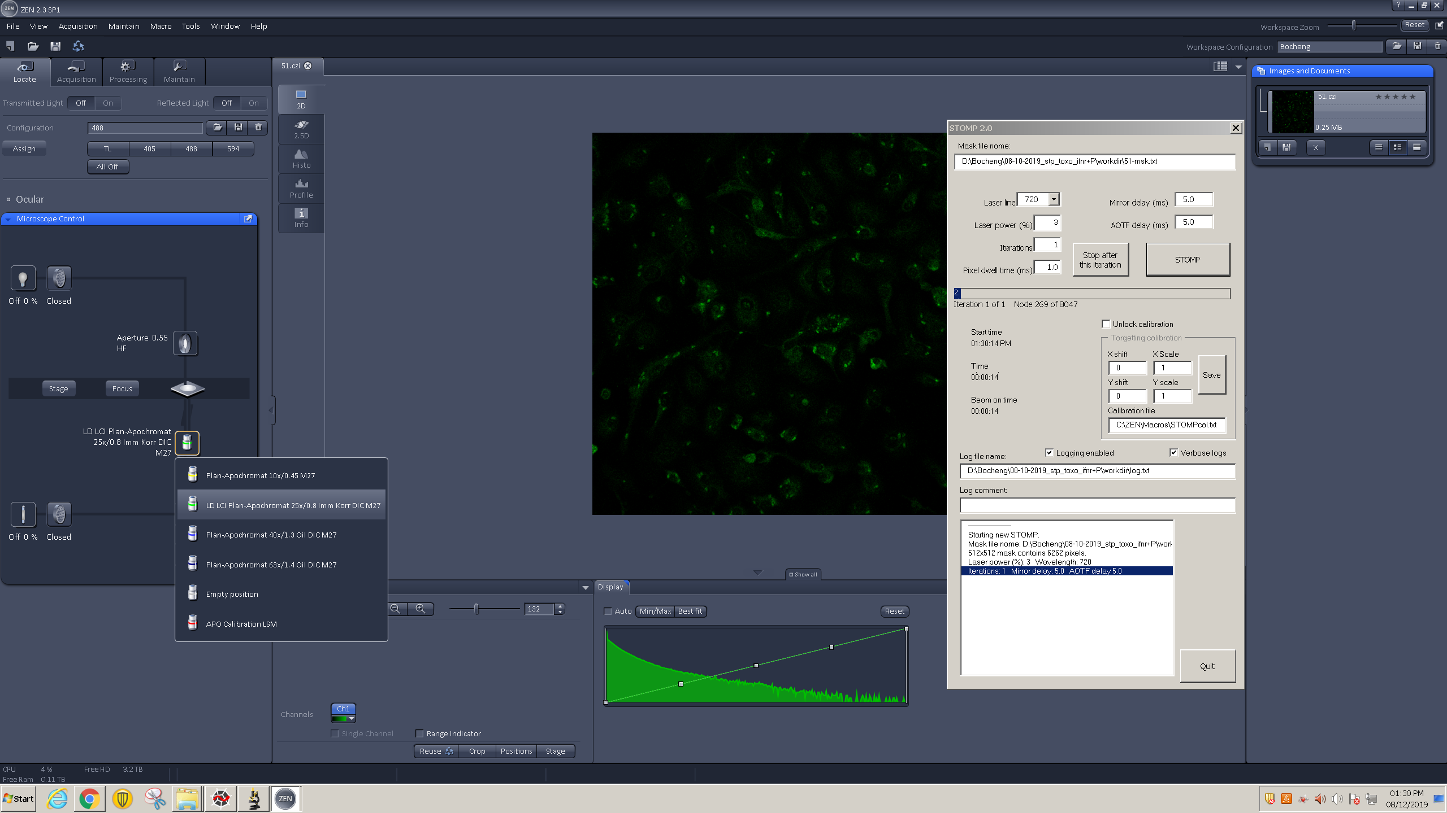

For this protocol the 25X oil immersion objective lens is used for STOMP.

## 1.2 Microscope PC configuration in Ewald lab:

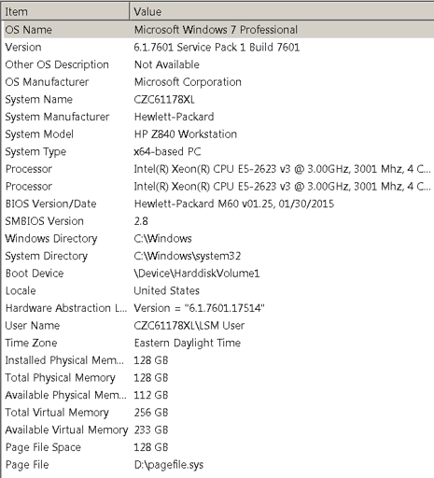

## 1.3 Applications needed:

1. ZEN Black: ZEISS application to operate the confocal microscope and two photon laser source hardware and perform image acquisition and UV targeting.
2. ImageJ/Fiji: open source application to modify images and generate mask files.
3. Spyder: Integrated development environment (IDE) for python code.
4. Sikulix: Icon recognition and automation platform for the Windows environment

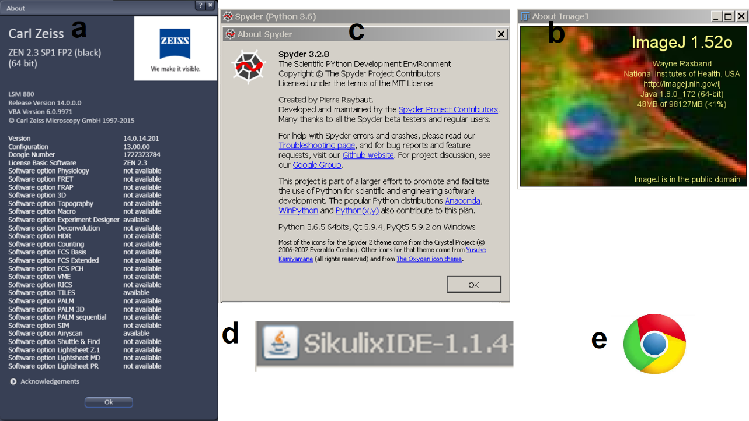

# Mount the slide with biotin-benzophenone

1. Prepare the slide right before autoSTOMP. 0.05 M stock solution of biotin-benzophenone in DMSO (protect from light) was made and stored at -30 oC.
2. make 1 mL working solution of 1 µM biotin-benzophenone in 1:1 DMSO:H2O.
3. Move to cold room. It is recommended to mount and seal the slide in the cold room. It is common to see bubbles forming inside when mounting is done at room temperature which could be ascribed to the rapid evaporation of 1:1 DMSO:H2O.
4. Wet slide with water to avoid bubbles.
5. Add 12 µL 1 µM biotin-benzophenone to section, cover with circular coverslip, making sure that liquid spreads across sample.
6. Fix coverslip in place by applying nail polish to small sections on either side of coverslip. Incubate for 10 minutes, protected from light.
7. Circle coverslip with nail polish. Incubate for 10 minutes, protected from light.
8. Add another layer of nail polish around the coverslip. Incubate for 10 minutes, protected from light.
9. Move the slide to the microscope room and keep in dark at RT for at least 20 min before autoSTOMP.

# Prepare microscope and desktop:

### 3.1 Prepare the LSM880 for imaging and load the slide on microscope stage: Start the system, manually inspect the sample.

### 3.2 Open the applications on Windows: ZEN Black, Fiji, Spyder, Sikulix.

### 3.3 Expand the block indicated below in ZEN black GUI:

* ZEN Black GUI occupies the whole screen all the time. Other applications either sit on top temporarily or hide in the background.
  + 1. Block 1: set up a multi-dimensional experiment

[1] “Positions”

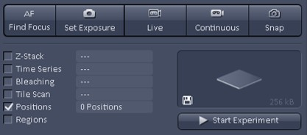

[2] “Tile Scan”

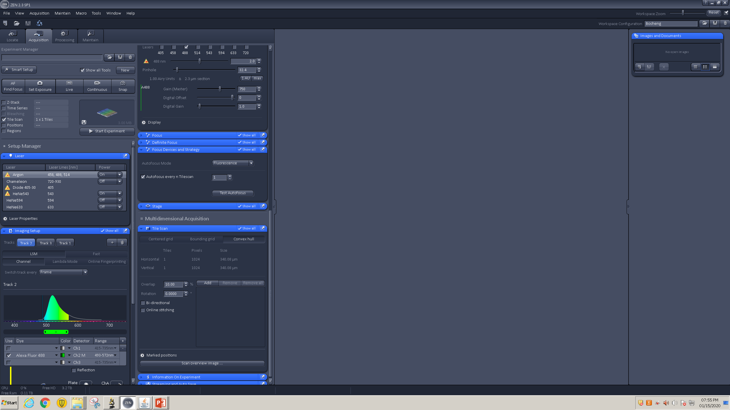

* + 1. Block 2: set up the lasers used for the experiment. These include the visible light lasers (488 and 594) according to the dyes used in section 1 for image acquisition and the multi-photon source (Chameleon) tuned to 720nm for photolabeling.

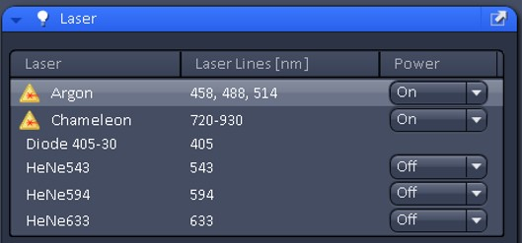



* + 1. Block 3: setup the autofocus by checking the “Autofocus every n Position” box and set the pulldown menu to 1. 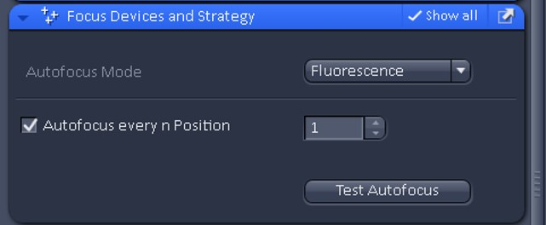
    2. Block 4:

[1] “Positions”

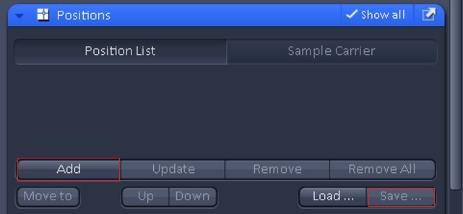

Options:

“Add”: add a location

“Save…”: save a position file, “xxx.pos”

“Load…”: load a position file, “xxx.pos”

[2] “Tile Scan”



Note: “convex hull” tile scan will be set with 0% overlap between tiles if running “multiTileScan.sikuli”

**WARNING: blocks 2, 3 and 4 in ZEN Black must not be blocked by other windows or GUIs. Otherwise, the Sikulix code will crash.**

* + 1. Block 5: the Windows task bar at the bottom of the window displays active applications.

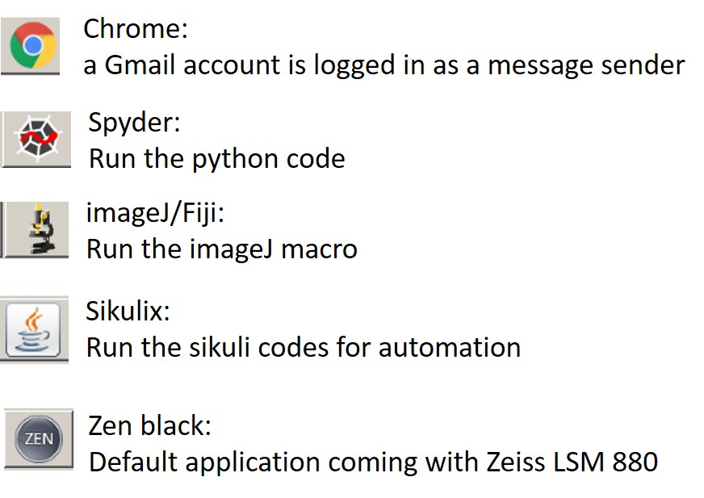

* + 1. Block 6: the drop-down menu in ZEN Black to load the STOMP macro. 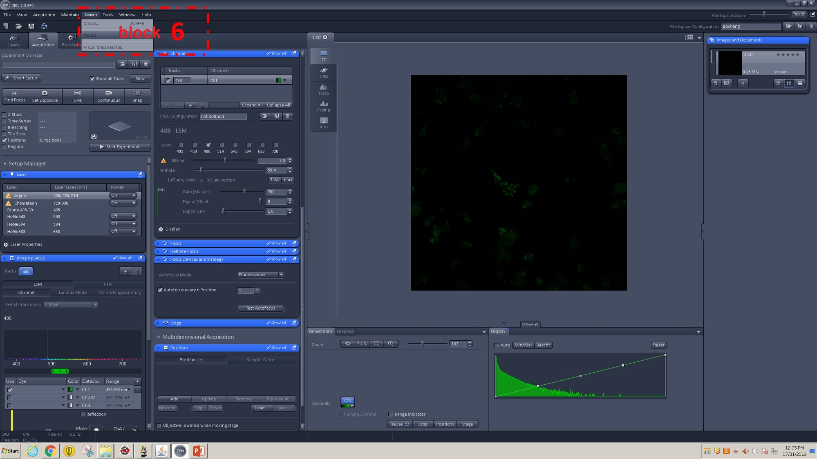
       - Enlarged view of Block 6: 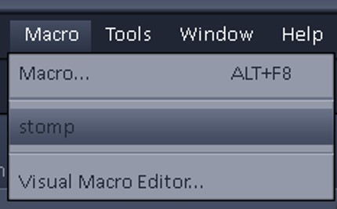

### 3.4 Set up GUI for Sikulix and Spyder

1. Block 7: GUI for Sikulix or Spyder – They are sitting on the top of the Zeiss black. Make sure it won’t cover the blocks 1-4.
2. Here are examples of Sikulix scripts. Each tab is an open script.

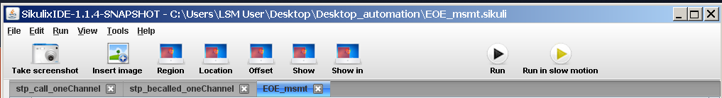

Representative Python scripts opened in Spyder:

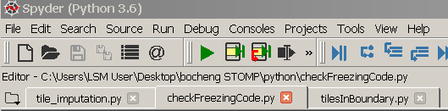

1. Block 8: Fiji (ImageJ) for image processing and MAP file generation. 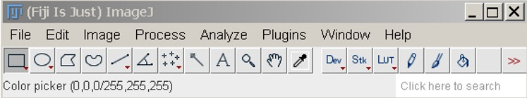

Note: Various Fiji macros can be installed in the menu “Plugins”.

1. Block 9: STOMP macro GUI in ZEN Black. Initiate the macro when instructed.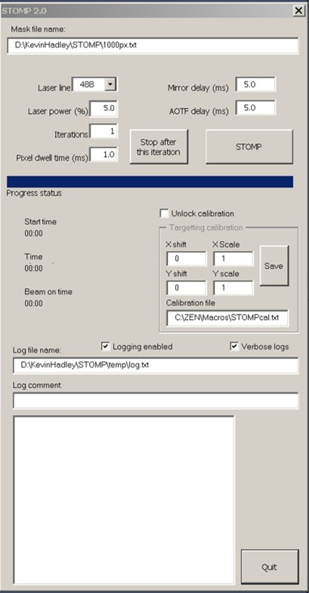

# Photo-crosslinking with two-photon laser

## 4.1 Setup imaging parameters in ZEN black:

[1] tune laser power and Gain to gain decent signal for each channel.

For instance, we need to tune the channel 488 and 543 in this example.

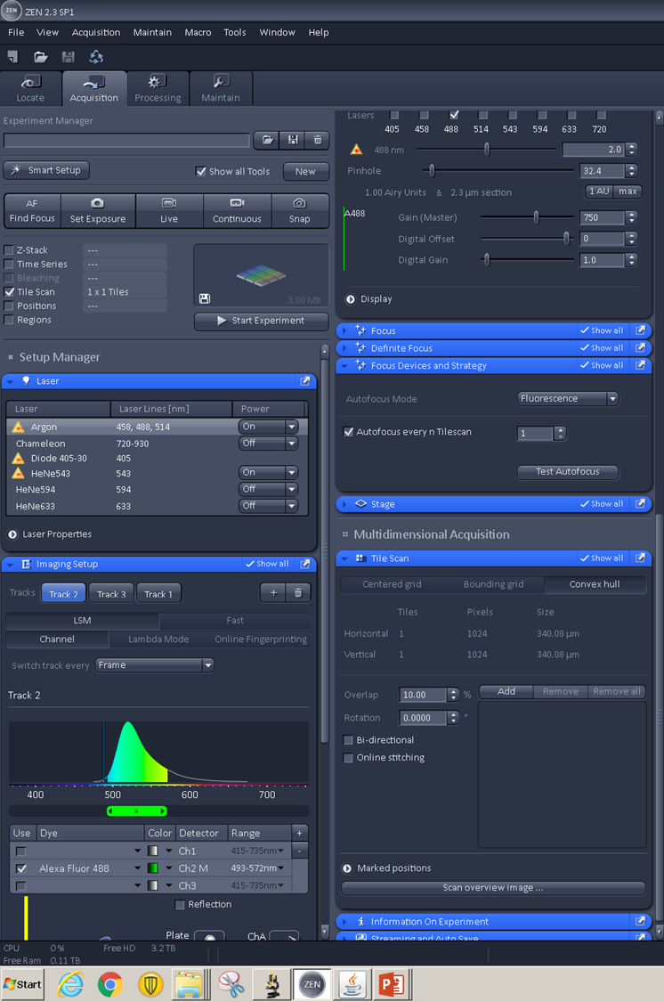

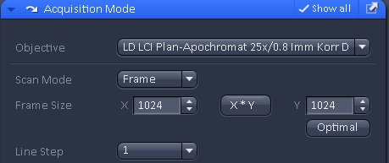

## workflow contains two parts:

* Warning
  + Familiarize yourself with the basics of Sikuli at http://sikulix.com/
  + Sikulix script is a hybrid of .png images and word codes. Directly use our Sikulix codes on a computer other than ours will fail with no doubt for many reasons. The Graphical user interface can change because of the variations in operating system, software version, layout and configuration.
  + Please adjust the similarity or replace the image in the script with the ones freshly captured from your local desktop, regardless that you will follow the exact same workflow within the same working environment as us.
  + Our codes are deposited to <https://github.com/boris2008/autoSTOMP_2.0.git>

### 4.2.1 Interactive tools to select interesting regions from single tissue section or multiple ones with “RegionSelection.sikuli”.

Parameters needs to be set up for your PC environment

[1]

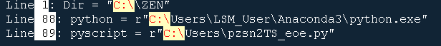

* Make sure the directory in Line 1 exists. Otherwise, specify a new one.
* The executable Python file must be specified on Line 88. Modified it if it is different on your system.
* Place “the pzsn2TS_eoe.py” in a folder you prefer. Specify its location in the Line 89
* “pwd_mROIs.txt” file will be generated and placed in the directory specified in Line 1. The file will be used by “STOMP.py”

### 4.2.2 Iterative photo crosslinking through tiles of SOIs with “STOMP.sikuli”

Parameters needs to be set up for your PC environment

[1]

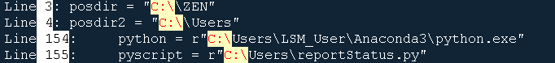

* Make sure the directories in Line 3 and 4 exists. Otherwise, specify new ones.
* The executable Python file must be specified on Line 154. Modified it if it is different on your system.
* Place “reportStatus.py” in a folder you prefer. Specify its location in the Line 155.
* Specify the sender, password, and receiver in the Lines 14-18 and 56-60 of the file “reportStatus.py”.

[2]



* For the first time user of the “STOMP.sikuli”. Place the example of “sikuliInput.txt” in the directory specified in Line 8. Place the example of “currentInfo.txt” in the directory specified in Line 43. The parameters can be corrected in the following steps.
* The files in Lines 8, 33, 43/45/67, 97 are the input files for “STOMP.sikuli”.
* The files in Line 122 and 139 are the output files of “STOMP.sikuli”

[3]



* The directory of the Python scripts should be specified.

[4]



* “Z:\” is the Map network drive set up in Windows for our cloud storage. The “currentInfo.txt’ allows us to monitor the STOMP status remotely in real-time.

### 4.2.3 “stp_becalled_oneChannel.sikuli” called by “STOMP.sikuli”

Parameters needs to be set up for your PC environment

[1]



* Make sure the directory in Line 8 exists. Otherwise, specify a new one.

[2]

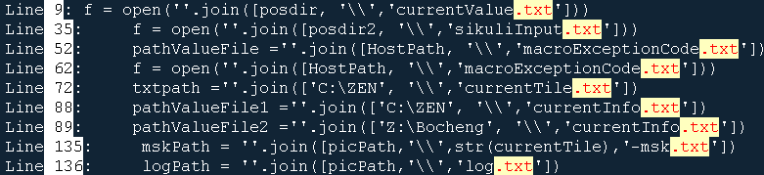

* The files in Lines 9 and 35 are the input files of “stp_becalled_oneChannel.sikuli”.
* The files in Lines 52, 62, 72, and 88/89 are the output files of “stp_becalled_oneChannel.sikuli”.
* The files in Lines 135 and 136 specified will be entered into the STOMP macro of ZEN black.

[3]



* “Z:\” is the Map network drive set up in Windows for our cloud storage. The “currentInfo.txt’ allows us to monitor the STOMP status remotely in real-time.

### 4.2.4 The Fiji (also imageJ) macros

[1] The file needs to be specified in “ROICo_sc.ijm”



[2] The file needs to be specified in “rat_scar_macrophage.ijm”



[3] The file needs to be specified in “MAP_sc.ijm”



### 4.2.5 Other Python scripts

[1] “tile_imputation.py”

Parameters needs to be set up for your PC environment







* Line 21-23, specify the file position or the directories.
* Line 42. The size of each field of view. 340.1 micrometer with 25x lens in our microscope.
* Line 46. The pixelsize = 0.66 micrometer in the 512x512 format images acquired by 25x lens.
* Line 47. The maximum numbers of tiles should be contained in each position file “.pos”.

[2] “checkFreezingCode.py”

Parameters needs to be set up for your PC environment



* Lines 9-11. Specify these file position or the directories.



* Specify the file position in Lines 72 and 96.

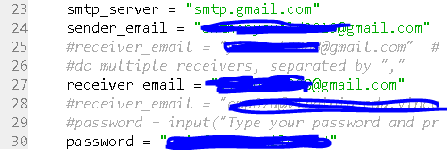

* Specify the sender’s email address and password.

## Let’s start!!!

Instructions will pop up at an appropriate time. Just follow it!

### 4.3.1 run “RegionSelection.sikuli” file in Sikulix

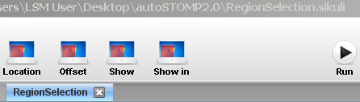

1. 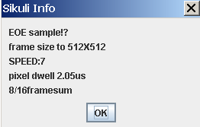

It reminds the user to set the imaging format to 512x512 and other acquisition parameters in the panel “Acquisition Mode”. Click OK after setting.

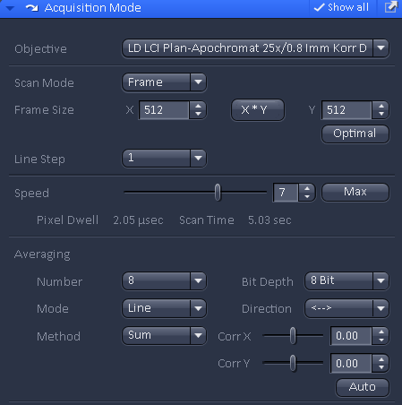

1. The window asks for the user’s input for a name of a working directory (~wd). Enter a name, for instance, “12-23-2020-test”. A new folder is created with three subfolders with paths, “~wd/tileScan”, “~wd/ROIs”, and “~wd/stpTile”. These folder paths information will be written into a log file named as “pwd_mROIs.txt” and placed in a fixed folder “C:/ZEN”. Every new run will overwrite the log file. Click “OK” after filling it.

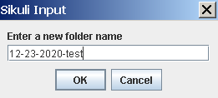

1. Set the multi-dimensional experiment to “Positions”, and click OK after finish.

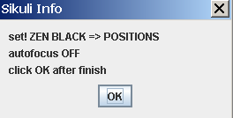

* 
* 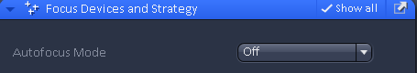

1. Begin to record a boundary points for a section 1. Click OK to proceed.

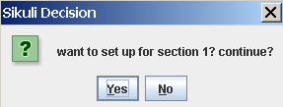

1. Begin to set up for section 1. Don’t click “YES”.

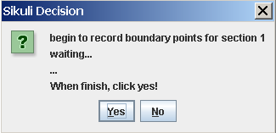

1. For every point, switch between the two modes, “Locate” and “Acquisition”

* In “Locate” mode, find a position with binocular.Back to “Acquisition” mode, add the position to the panel as shown below.



* Back and forth several times to add enough points, like 8 points.
* Click “Yes”



* Watch the automation to save the positions for section 1 until the next window pops up.

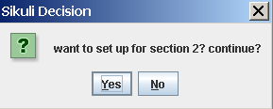

Choose “Yes” if a next section exists. Otherwise, choose “NO”.

* Confirm if you have set all the sections.

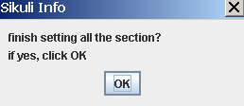

1. Set up tile scan. Don’t click “OK”.

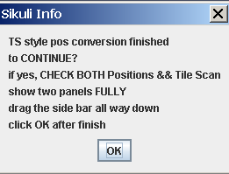

* Check Tile scan in “Experimental Manager”
* Expands the panels of “Tile scan” and “Positions” under “Multidimensional Acquisition”. Slide the side bar all the way down to the bottom.

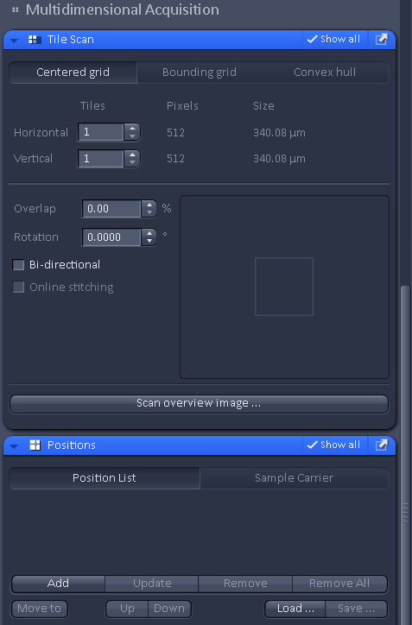

Side bar

* Click “OK” when finish.

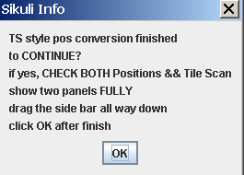

1. Watch the automation until a new window pops up. Do not click “OK”.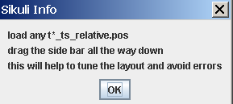

* Click the “load” button inside the “tile scan” panel. Choose a “t*_ts_relative.pos” file to open then drag the side bar all the way down to the bottom.

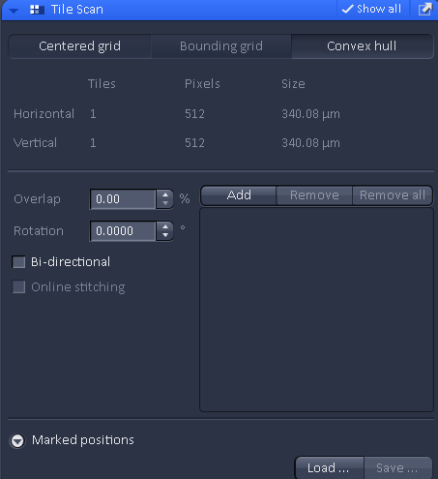

* Click “OK” when finish.



1. Watch the automation until a new window pops up. The tile scan image of each section will be saved automatically.
2. The window pops up to instruct the user to call the macro in Fiji from where it is located.

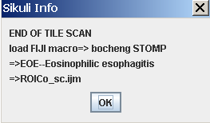

Click “OK”. The job of “RegionSelection.sikuli’ finishes and its window appears on. Minimize its window.

### 4.3.2 open Fiji and install the macro “ROICo_sc.ijm”

1. Install the macro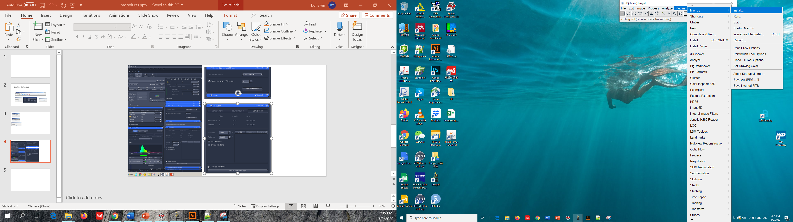
2. Once it is installed, it will show as below. Type “g” to start the macro.

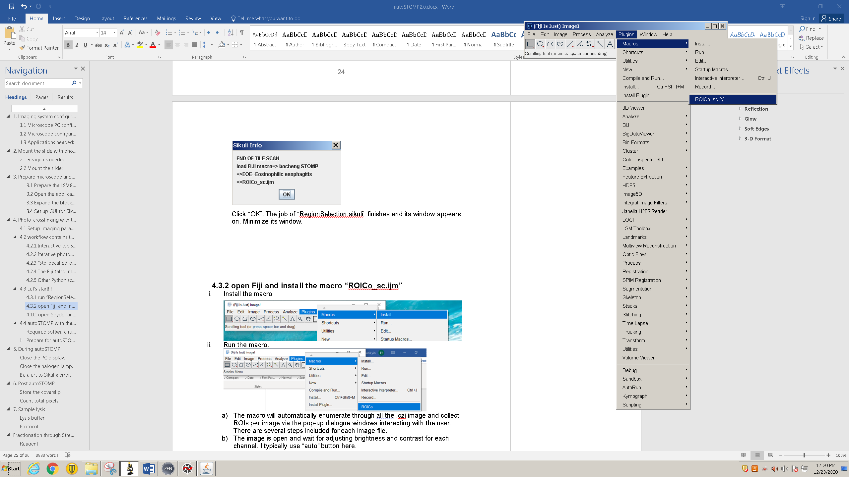

1. Click “OK” in the window  to open the image for section 1.
2. Click “Auto” to automatically change the brightness and constrast of the image.

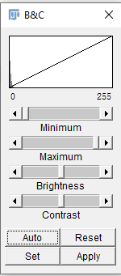

Then click “OK” in the window as below

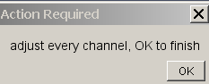

Two new windows pop up.

1. “Free hand” tool is set as the default tool. The user can manually draw out ROIs on the open image (an example, left), and add every ROI into the ROI manager (right).

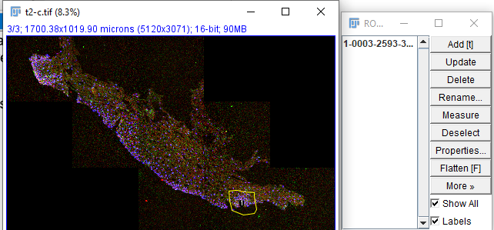

1. click OK when finishing section 1

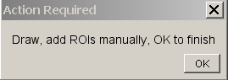

1. move on to a next section. When finishing all the sections, a new window pops up.

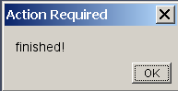

Click “OK” to proceed.

1. A new window pops up to instruct the user to use spyder IDE. Click “OK”.

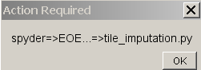

### 4.3.3 open Spyder and run the script, “tile_imputation.py”

1. 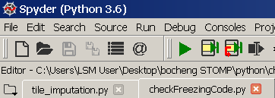

Click the 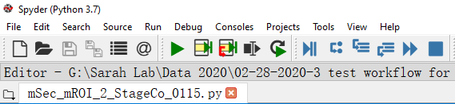 button to run. The imputation finishes within 1 min, then a message (as shown below) in the IPython console instructs the user to call “STOMP.sikuli”.

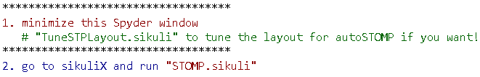

### 4.3.4 run “STOMP.sikuli” file in Sikulix

1. Follow the instructions in the pop-up window, turn off the tile scan by unchecking “tile scan”.



1. Turn the autofocus as suggested and set up the acquisition parameters. Click “OK” when finish.

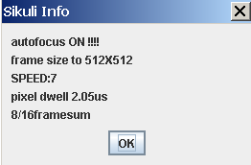

1. Load the “rat_scar_macrophage.ijm” for STOMPing macrophage in rat scar tissue or “MAP_sc.ijm” for STOMPing EoE lgG4 staining in Fiji as instructed. check section 4.3.2 to learn how to install the Fiji macro. Click “OK” when finish.

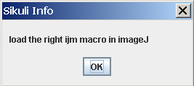

1. Instruct the user to load the STOMP macro, click “OK” after finish.

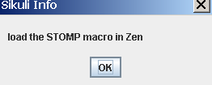

* Install the “STOMP.lvb” in ZEN black.

Hadley, K. C.; Rakhit, R.; Guo, H.; Sun, Y.; Jonkman, J. E. N.; McLaurin, J.; Hazrati, L.-N.; Emili, A.; Chakrabartty, A. Determining Composition of Micron-Scale Protein Deposits in Neurodegenerative Disease by Spatially Targeted Optical Microproteomics. *eLife* **2015**, *4*, e09579  DOI: 10.7554/eLife.09579

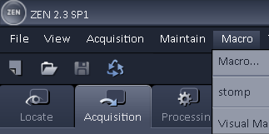

Once installed, a window will pop up as below.

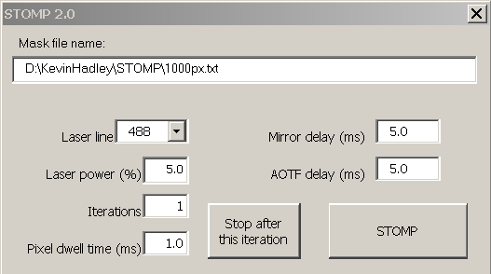

1. There are consecutive windows asking for the user’s inputs. Adequate hints have been provided. Rolling through the windows by clicking “OK” when finish at each step.

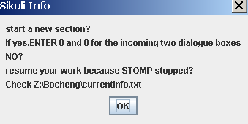

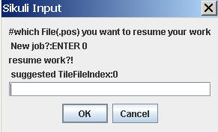

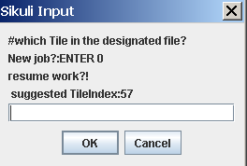

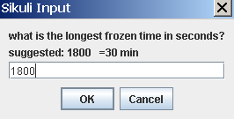

* Instruct the user to run the Python script which will monitor the autoSTOMP status.

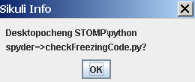

* Go to Spyder and click the  button to run the “checkFreezingCode.py” script.

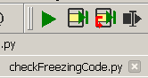

1. Once click “OK”, the automated photo-crosslinking starts until looping through all the tiles. The user just hands off and the autoSTOMP runs in the dark.



# During autoSTOMP

## Turn off the halogen lamp.

The halogen lamp has limited bulb lifetime and doesn’t need to be ON during Sikulix run. But you must turn the lamp back on and restart the Zen Black before starting STOMPing on a new slide.

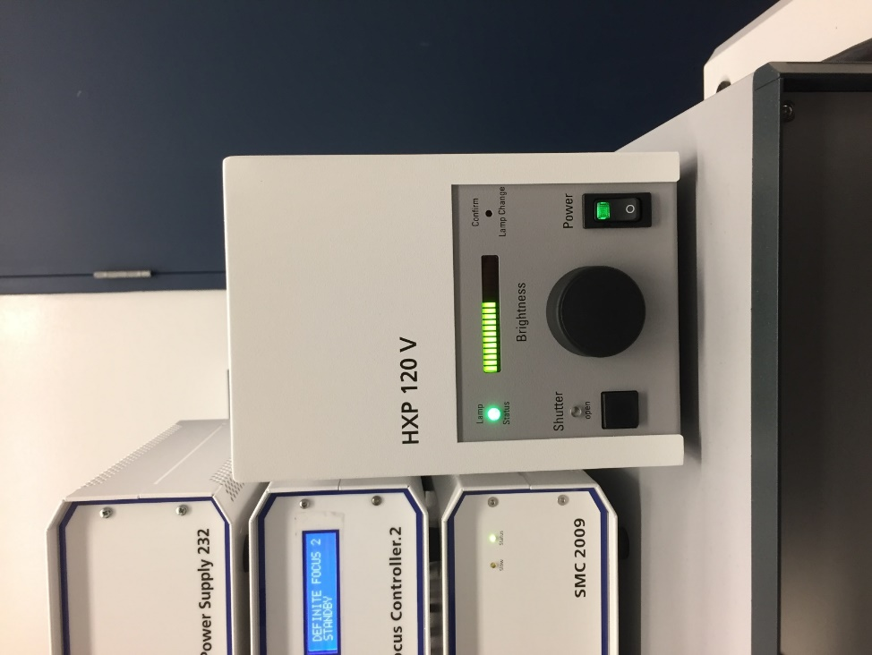

## Turn off the PC display.

The display does not need to be on all the time

## Troubleshooting SikuliX errors.

* + Search in Google. Your best friend.
  + If Sikulix crashes, record the error message. A typical simple solution would be replacing an image imbedded in a code line with freshly cropped one from the desktop to amend the Sikulix script. The “STOMP.sikuli” is upgraded from the Sikuli codes in <https://github.com/boris2008/Sikulix-automates-a-workflow-performed-in-multiple-software-platforms-in-Windows>.
  + Post your error in the sikulix launch pad. <https://answers.launchpad.net/sikuli>. Kind programmers and user will provide their suggestions.

# Post autoSTOMP

## Tissue section cleaning and storage

**Several coverslips are usually necessary to tag sufficient protein for mass spec.**

* 1. Once UV-cross linking is complete, unload the slide from the microscope. Clean immersion oil with lens cleaning liquid.
  2. Soak the slide in de-ionized water for at least 30 minutes at RT, gently shaking in the dark.
  3. Gently peel off the nail polish seal securing the coverslip to the slide.
  4. Wash the un-crosslinked biotin-benzophenone off of the tissue section with 1:1 DMSO:water, wait 5 minutes, aspirate. Repeat 3 times.
  5. Rinse the slide with DI water. Dry in the air briefly and store -30 oC or -80 oC freezer in the dark.

## Count total pixels.

Run the script, “TotalPixels_allLogs.py” in Spyder IDE.



* Specify the location of the log files in Line 16.

# Sample lysis

## 7.1 lyze rat scar tissue

Reagents needed:

* NH2OH lysis buffer (prepare fresh under fume hood):
* Add 2.42 g urea
* Add 0.5 mL 2 M K2CO3
* Add 1 mL H2O
* Adjust pH to 9 by adding 0.39 mL 10 M NaOH
* Dissolve 347.45 mg NH2OH-HCl in 1 mL H2O and add it to the solution above.
* Add more water if necessary, to fill the final volume to 5 mL.
* The final concentration of NH2OH is 1 M.
* For the lysis buffer: gas with N2 for 1 minute.
* xylene (for removing traces of immunePen mark from around sample)
* 1 M HCl

Protocol:

1. Take slides out of freezer to warm up at the room temperature for 5 min.
2. Label tubes for samples. Add 0.4 mL H2O to each tube.

WARNING: Be careful when handling tissue sections. Thin sections are easily blown away by ordinary breathing – wear a face-mask.

1. Dip a cotton swap in xylene and remove the immunePen mark left surrounding tissue section.
2. Wear facial mask to avoid your breath from blowing away the scrapped section.
3. Use a razor blade to scrape the tissue section off the slide and tap the tissue sections with the tip of a cotton swab (with the cotton removed and dipped in water) gently. Quickly transfer it to its respective tube by dipping the tip in the water and lifting to release the tissue section. Make sure that the sample actually stays in the tube!
4. Centrifuge samples (20,000 x g, 10 minutes). Remove H2O carefully to avoid disturbing samples.
5. Add 100 µL NH2OH lysis buffer.
6. Incubate on a thermo-shaker for 17 hours with shaking (400 rpm, 45 oC).
7. Vortex sample. Centrifuge at 20,000 x g, 10 minutes, RT. Collect the supernatant to a new tube.
8. Neutralize pH to ~7.4 by adding 20 µL 1 M HCl for every 100 µL of lysis/digest buffer. Vortex.

## 7.2 lyze EoE tissue

Reagents needed:

o DTT/SDS boiling buffer (prepare fresh under fume hood): 0.1 M Tris-HCl, pH=8.0, 0.1 M DTT, 4% SDS

o xylene (for removing traces of immunePen mark from around sample)

Protocol:

* + - 1. Take slides out of freezer to warm up at the room temperature for 5 min. Dry the sample in the air.
      2. Label tubes for samples, add 0.4 mL H2O to each tube.

WARNING: Be careful when handling tissue sections. Thin sections are easily blown away by ordinary breathing – wear a face-mask.

* + - 1. Dip a cotton swap in xylene and use it to remove traces of immunePen mark left surrounding tissue section.
      2. Wear facial mask to avoid your breath from blowing away the scrapped section.
      3. Use a razor blade to scrape the tissue section off the slide and tap it with the tip of a cotton swab (with the cotton removed and dipped in water) gently. Quickly transfer it to its respective tube by dipping the tip in the water and lifting to release the tissue section. Make sure that the sample actually stays in the tube!
      4. Centrifuge samples (20,000 x g, 10 minutes). Remove H2O carefully to avoid disturbing samples.
      5. Add 100 µL DTT/SDS boiling buffer.
      6. Incubate on a thermo-shaker for 1 hour with shaking (600 rpm, 99 oC).
      7. The crude extract was clarified by centrifugation at 20000 x g at room temperature for 10 min. Collect the supernatant.

# 8. Fractionation through Streptavidin precipitation

## Reagent

* TBS buffer: 50 mM Tris-Cl, 150 mM NaCl at pH = 7.4
* 0.1% SDS/TBS: TBS spiked with 0.1% SDS
* TBST: TBS spiked with 0.1% SDS + 0.1% tween 20
* ambic buffer: 100 mM NH4HCO3 in water
* SA bead: Pierce™ Streptavidin (SA) Magnetic Beads (88817) 50% slurry

## Protocol

1. The lysate was diluted in TBST at a volume ratio of 1:9, and vortex. Split the solution if it is larger than 1 mL into another one or more 1.5 mL microtubes.
2. For the lysate from the total tissue weight ~ 1-2 mg (4~6 rat scar sections, or 16~28 EoE biopsy sections, the numbers of tissue sections varies dependent on the section size and thickness. Here our cryosection thickness is 7 μm), every 15 ~ 20 μL SA bead was used. The SA bead slurry was directly added into the diluted lysate, and vortex. Incubate for 1 hour at RT with a slow rotation (~12 rpm).
3. The magnet (DynaMagTM-2, Invitrogen) was to pull down the magnetic beads in 1.5 mL microtubes. Incubate on magnet for 3 minutes. Slowly collect the supernatant with a pipet. Do not use a vacuum or any strong aspiration. This supernatant is saved as an internal control, the flow-through. The proteins of flow-through was precipitated via spiking the trifluoroacetic acid to a final concentration of 20% (v/v) and incubate on ice for at least 2 h or overnight in 4 oC. The sample was pelleted at centrifugation at 20000 g for 15 min followed by the supernatant discarded. The sample was incubated in pre-chilled acetone for 10 min at room temperature followed by the removal of the wash solvent with centrifugation at 20000 g for 10 min and gentle aspiration with a pipet. Wash with pre-chilled acetone was repeated for additional two times.
4. Add 1 mL 0.1% SDS-TBS (no tween 20 included) per microtube and vortex to resuspend the SA beads. Incubate on the roller for 5 minutes, then incubate on the magnet for 3 minutes. Slowly remove the supernatant with a pipet.
5. Repeat step 4 with five more times.
6. Add 1 mL 0.1% SDS-TBS (no tween 20), to suspend the beads and transfer to a clean new vial to minimize the carry-over of the detergent (tween 20). Pellet the beads on magnet as step 4.
7. Add 1 mL 100 mM ammonium bicarbonate, vortex at low speed ~1000 rpm to suspend the beads. Sit on the bench for 5 min, then pellet the beads on magnet for 3 min, and carefully remove the supernatant with a pipet.
8. Repeat step 7 two more times.
9. Resuspend in 100 µL 100 mM ammonium bicarbonate. vortex at low speed ~1000 rpm to suspend the beads. Submit to the Mass Spec core lab for on-bead digestion and desalting as the autoSTOMP portion. Note: Portion of the SA beads sticking to the plastic vial vary from sample to sample, preparation time to time. This part cannot be brought to the solution and its bound protein cannot be recovered on-bead trypsin digestion
10. The protein pellet of the flow-through in step 3 was submitted to Mass Spec core lab for in solution digestion and desalting as the complement portion, flow-through.